8 Team Consolation Tournament

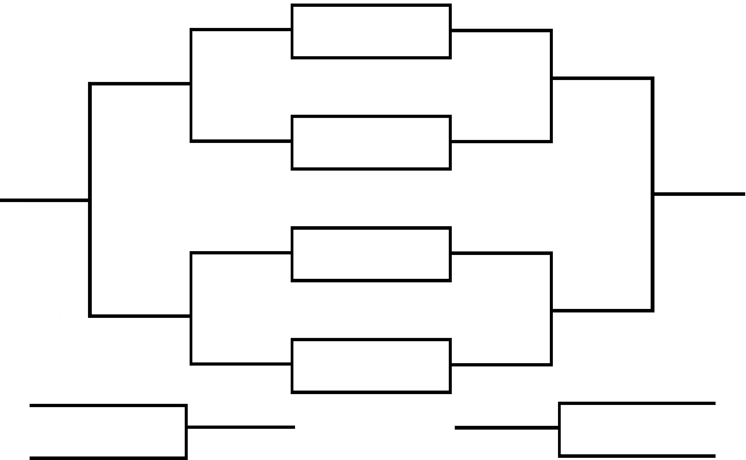
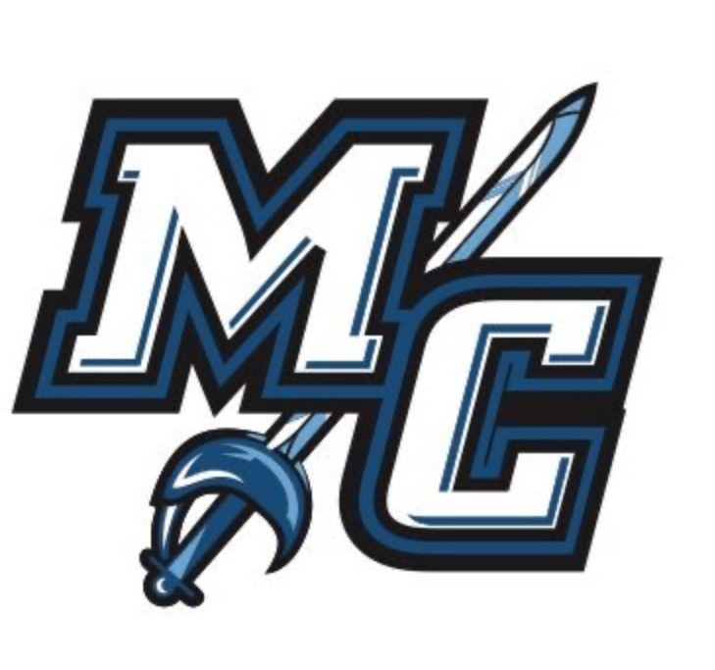
WE ARE MC INVITATIONAL

Friday, November 7th 12:00PM
Game 5

LA Valley

Thursday, November 6th 1:00pm
Game 1
PASADENA

Friday, November 7th 4:00PM
Game 7

Consolation Champions

Saturday, November 8th 1:00PM
Game 11

Consolation Bracket

SAN JOSE CITY

Thursday, November 6th

3:00PM
Game 2
RIVERSIDE

SOLANO COLLEGE

Thursday, November 6th

7:00PM
Game 3
COLLEGE OF THE CANYONS

Winner’s Bracket

Saturday, November 8th

5:00PM
Game 12

Champions

Friday, November 7th

2:00PM
Game 6

EAST LA
Thursday, November 6th
5:00PM
Game 4
MOORPARK

Friday, November 7th 6:00PM
Game 8

Game 9 – Loser of 5 vs Loser of 6

7th place -Saturday, November 8th - 11:00AM

3rd place -Saturday, November 8th 3:00PM

Game 10 – Loser of 7 vs Loser of 8

Kenneth Plummer
2025-10-05 14:04:23
--------------------------------------------
Valley

